Investigating change in NMB

The decision Tree:

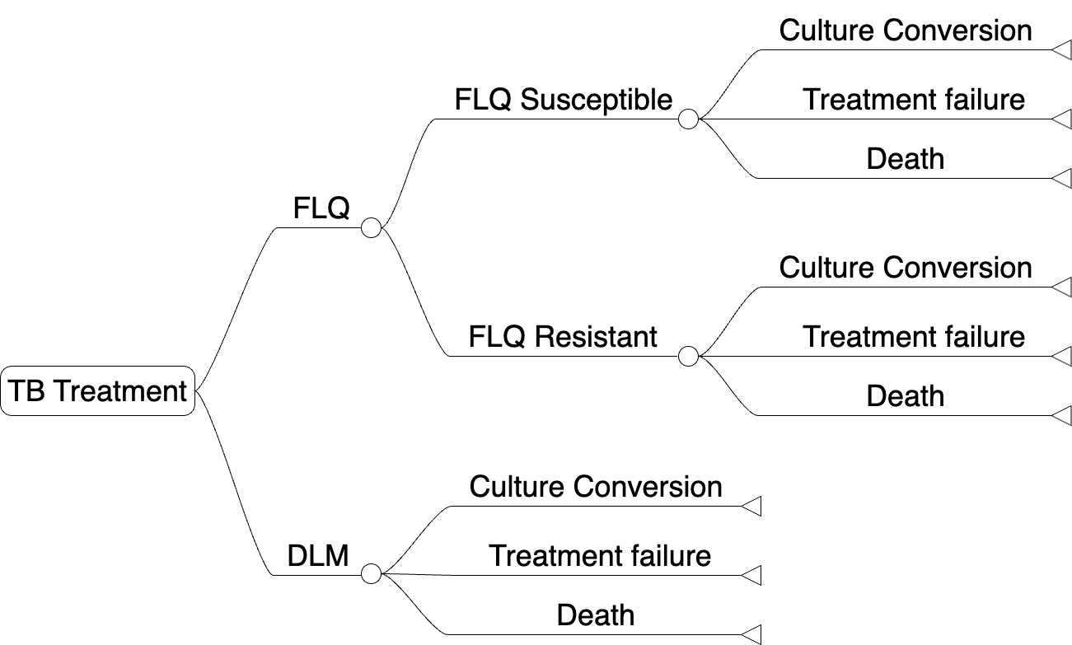

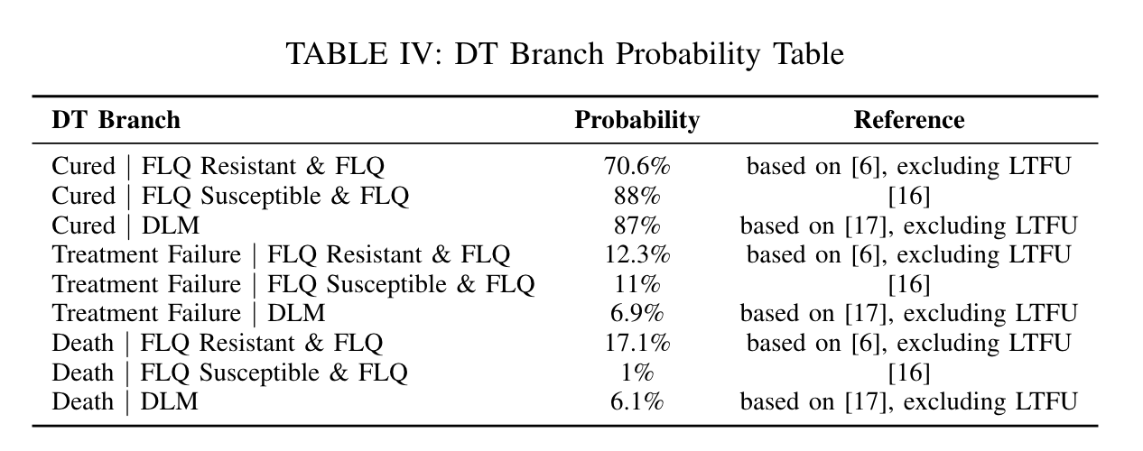

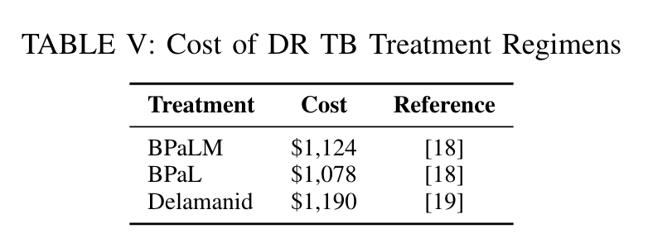

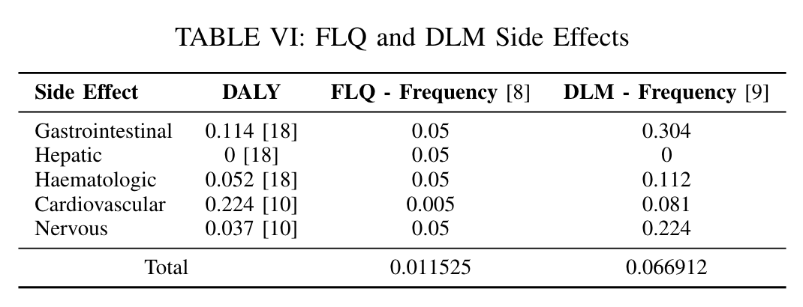

Probabilities in the DT:

[RY:
For patient $i$:
—— If prediction model is not available ——
- Calculate the expected cost, DALY, and loss in NMB if we give the patient the standard regimen (note that you can use the upper arm in the DT above but the probability of resistant to FLQ should be set to the prevalence of resistant to FLQ in the dataset) This gives -> $C_{i}$, $Q_{i}$, $NB_{i}$.
- Given that we know the patient’s resistance profile, calculate the expected cost, DALY, and loss in NMB -> ${\hat{C}}_{i}$, ${\hat{Q}}_{i}$, ${\hat{NB}}_{i}$.
- Report $\overline{C}$ (the average of $C_{i}$s), $\overline{Q}$ (the average of $Q_{i}$s), and $\overline{NB}$ (the average of ${NM}_{i}$s) and $\overline{\hat{C}}$, $\overline{\hat{Q}}$, and $\overline{\hat{NB}}$ overall and by true resistance profile.
  - It would be great to put these in 2 tables, each with 3 rows (for all, FLQ-S, FLQ-R) and 3 columns (for cost, DALY, and loss in NMB).
—— If prediction model is available ——
- Use the predictive model to classify the patient as either FLQ-S or FLQ-R
- If the patient is classified as FLQ-S:
  - Calculate the expected cost, DALY, and loss in NMB if we give FLQ (upper arm of DT with probabilities calculated according to the figure above) -> $C_{i,S,FLQ}$, $Q_{i,S,FLQ}$, $NB_{i,S,FLQ}$.
  - Calculate the expected cost, DALY, and loss in NMB if we give DLM (lower arm of DT) -> $C_{i,S,DLM}$, $Q_{i,S,DLM}$, $NB_{i,S,DLM}$.
Else if the patient is classified as FLQ-R:
  - Calculate the expected cost, DALY, and loss in NMB if we give FLQ (upper arm of DT with probabilities calculated according to the figure above) -> $C_{i,R,FLQ}$, $Q_{i,R,FLQ}$, $NB_{i,R,FLQ}$.
  - Calculate the expected cost, DALY, and loss in NMB if we give DLM (lower arm of DT) -> $C_{i,R,DLM}$, $Q_{i,R,DLM}$, $NB_{i,R,DLM}$.
- Decide what to prescribe for the patient:
  - If the patient is classified as FLQ-S, if $NB_{i,S,FLQ}<NB_{i,S,DLM}$ do FLQ else do DLM.
  - Else if the patient is classified as FLQ-R, if $NB_{i,R,FLQ}<NB_{i,R,DLM}$ do FLQ else do DLM.
- Record the actual outcomes:
  - We know the true resistance profile of the patient, so given the treatment we prescribed, we could calculate the expected cost, DALY, and loss in NMB for this patient: ${\hat{C}}_{i,DT}$, ${\hat{Q}}_{i,DT}$, ${\hat{NB}}_{i,DT}$.
  - Let’s also record ${\hat{C}}_{i,DT}$, ${\hat{Q}}_{i,DT}$, ${\hat{NB}}_{i,DT}$ by the actual resistance profile:
    - ${\hat{C}}_{i,DT,S}$, ${\hat{Q}}_{i,DT,S}$, ${\hat{NB}}_{i,DT,S}$
    - ${\hat{C}}_{i,DT,R}$, ${\hat{Q}}_{i,DT,R}$, ${\hat{NB}}_{i,DT,R}$
  - Calculate $ΔC_{i}={\hat{C}}_{i,DT}-{\hat{C}}_{i}$, $ΔQ_{i}={\hat{Q}}_{i,DT}-{\hat{Q}}_{i}$, $ΔNB_{i}={\hat{NB}}_{i}-{\hat{NB}}_{i,DT}$ (gain in NB from using the model).
    - Let’s also report these by true resistance profile.
Summary:
- A figure with 3 panels:
  - For all, % of people classified as FLQ-R varying by threshold.
  - For true susceptible: % of people classified as FLQ-R varying by threshold.
  - For true resistant: % of people classified as FLQ-R varying by threshold.
- A figure with 3 panels:
  - For all, % of all people receiving DLM varying by threshold.
  - For true susceptible: % of people susceptible receiving DLM varying by threshold.
  - For true resistant: % of people resistant receiving DLM varying by threshold.
- [Deleted]
- A figure with 9 panels:
  - Cost first row:
    - For all, ${\overline{\hat{C}}}_{DT}$ varying by threshold.
    - For true susceptible: show ${\overline{\hat{C}}}_{DT,S}$ varying by threshold.
    - For true resistant: show ${\overline{\hat{C}}}_{DT},S$ varying by threshold.
  - DALY second row: similar to first row but for DALY
  - NB Loss third row: similar to first row but for NB
- A figure with 9 panels:
  - Cost first row:
    - For all, show $\overline{ΔC}$ varying by threshold.
    - For true susceptible: show $\overline{ΔC}$ varying by threshold.
    - For true resistant: show $\overline{ΔC}$ varying by threshold.
  - DALY second row: similar to first row but for DALY
  - NB Loss third row: similar to first row but for NB
- A figure with 6 panels:
  - Cost first row: with 2 panels:
    - For true susceptible: show ${\overline{C}}_{S,FLQ}$ and ${\overline{C}}_{S,DLM}$
    - For true resistant: show ${\overline{C}}_{R,FLQ}$ and ${\overline{C}}_{R,DLM}$
  - DALY second row: similar to first row but for DALY
  - NB Loss third row: similar to first row but for NB
]

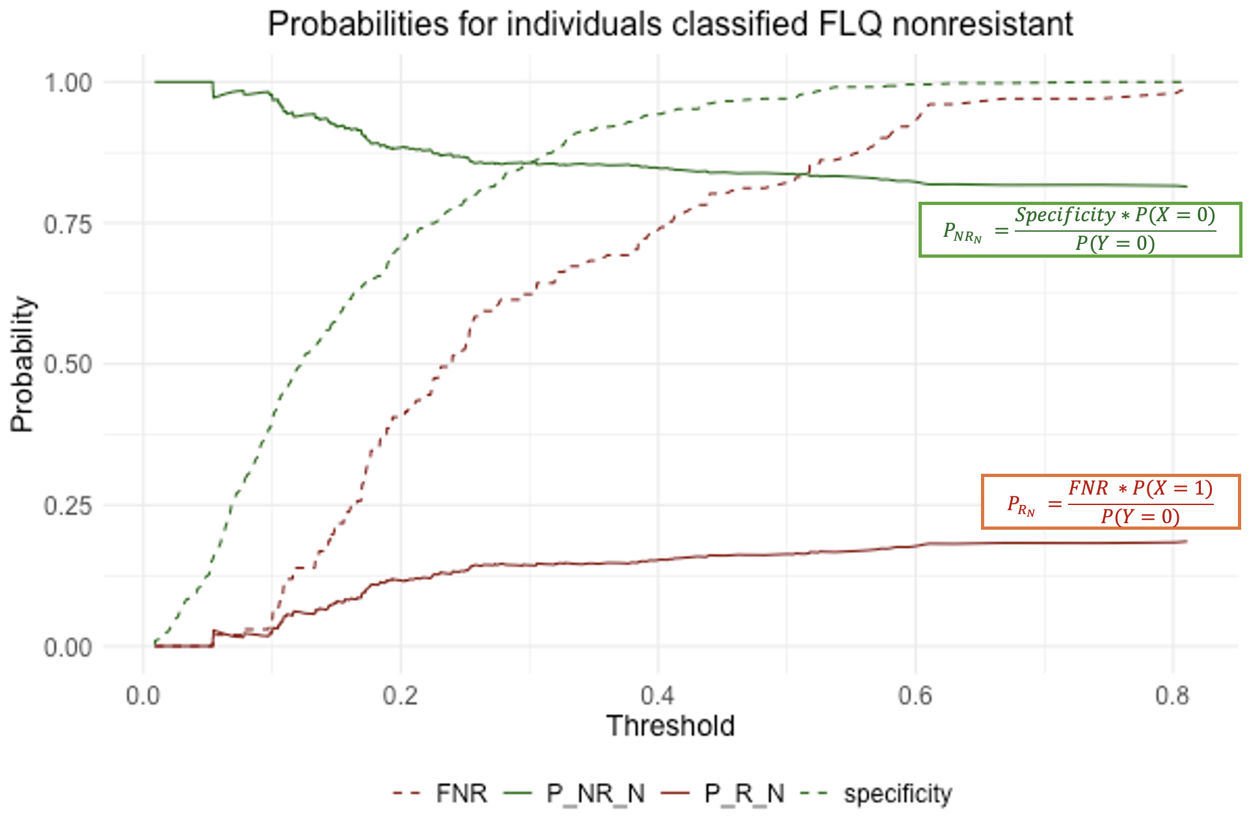 | 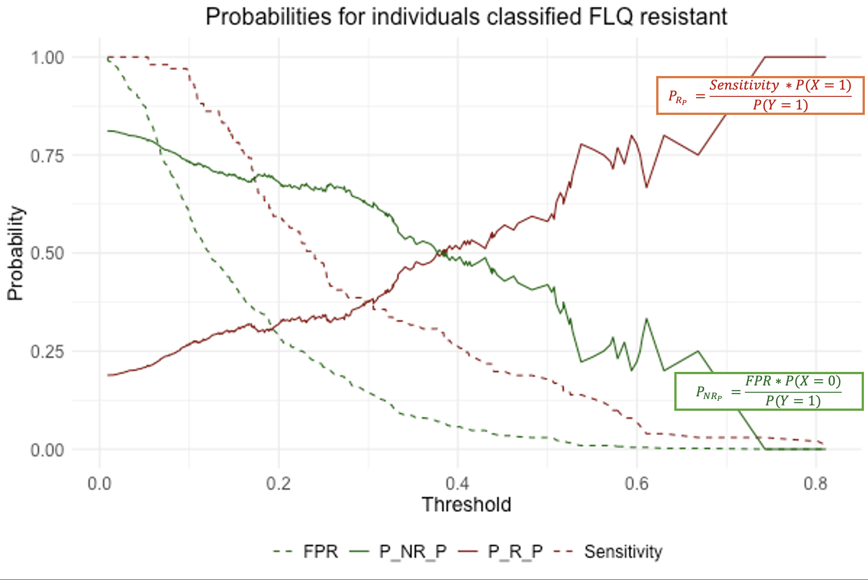

Figure 1
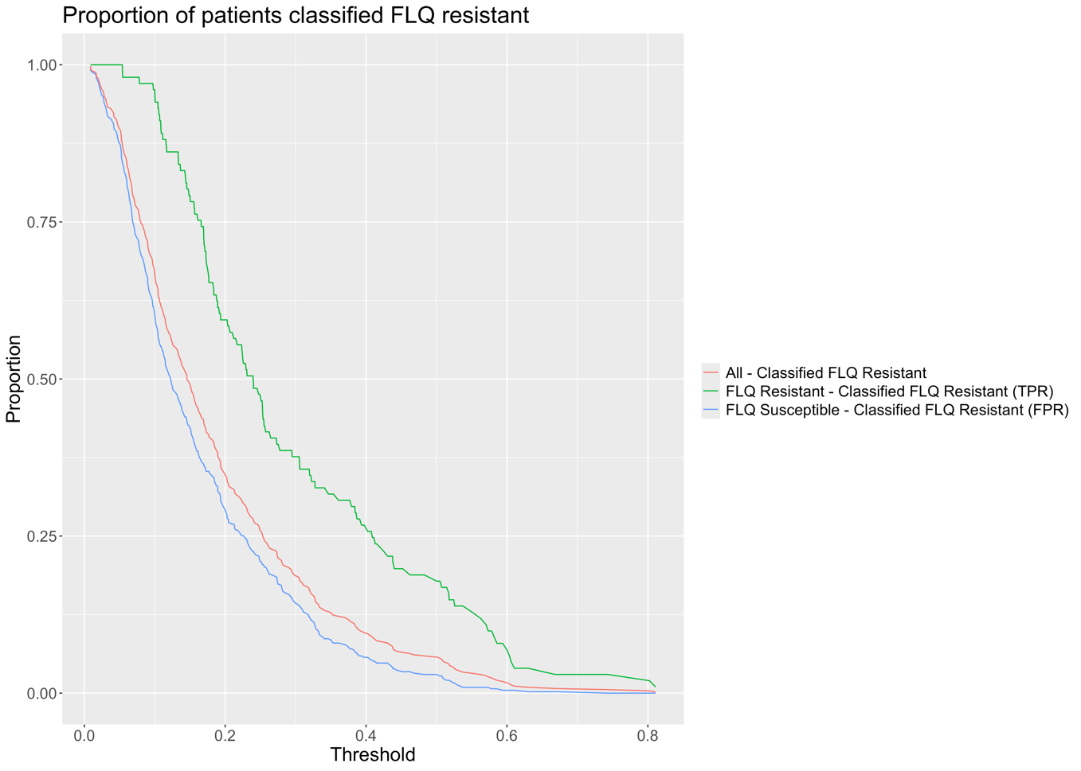

Figure 2
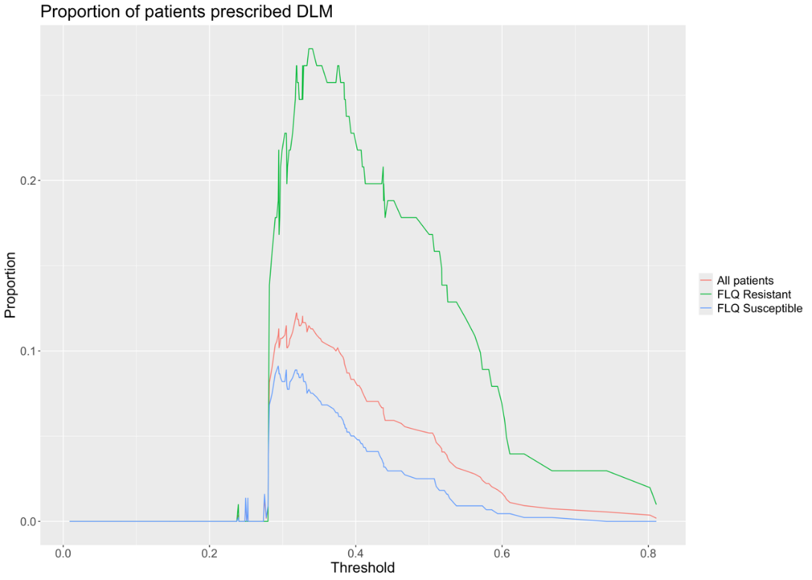

Figures 4 and 5
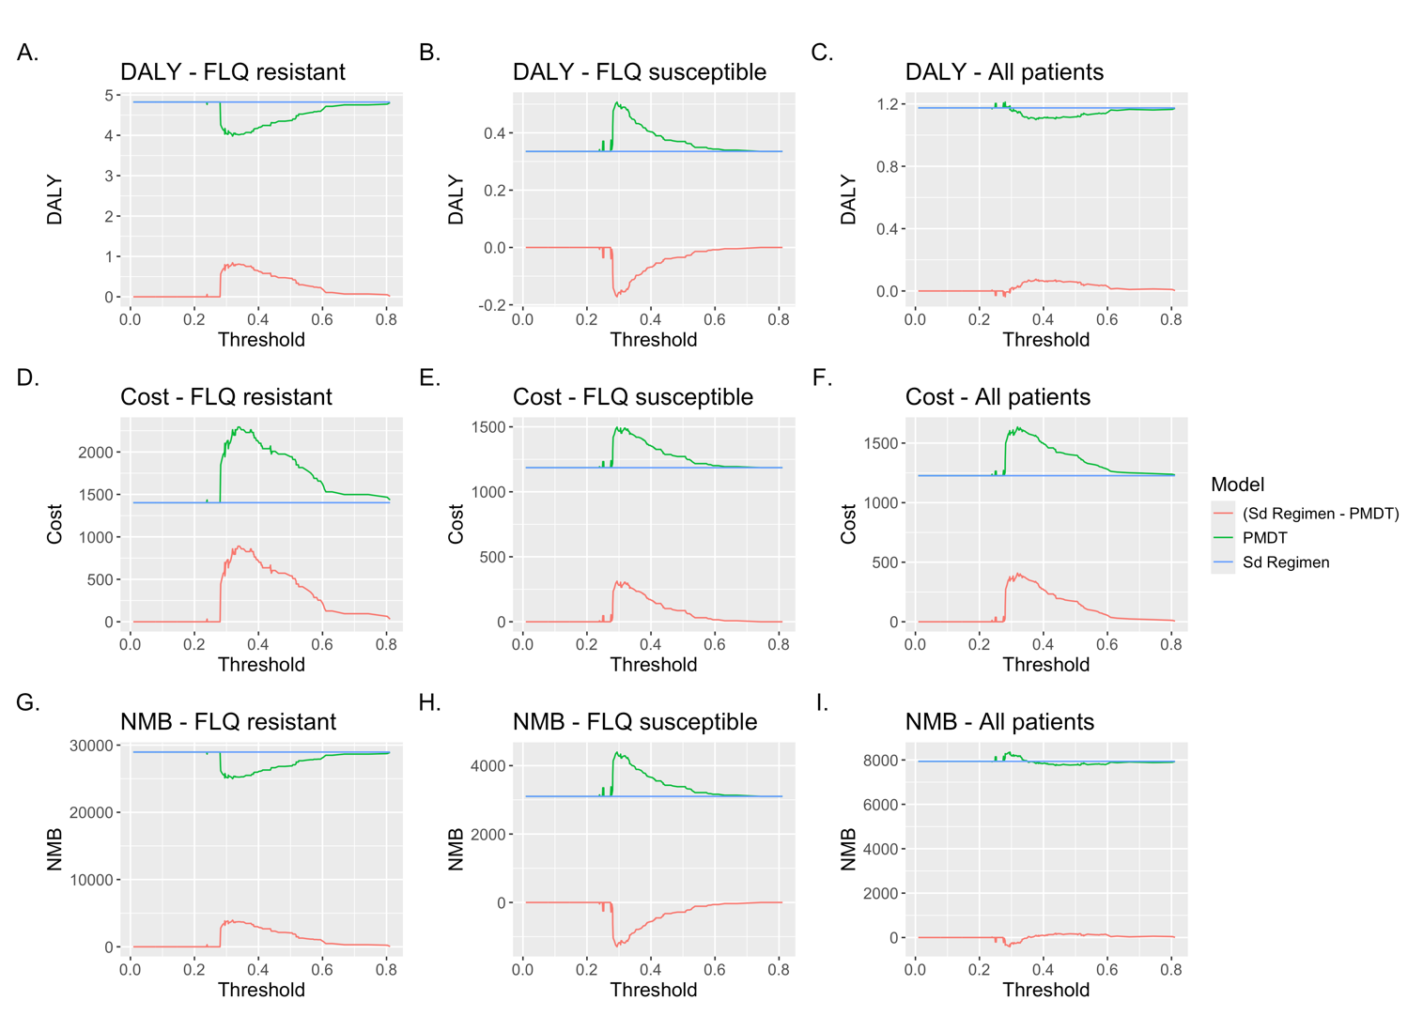

Figure 6
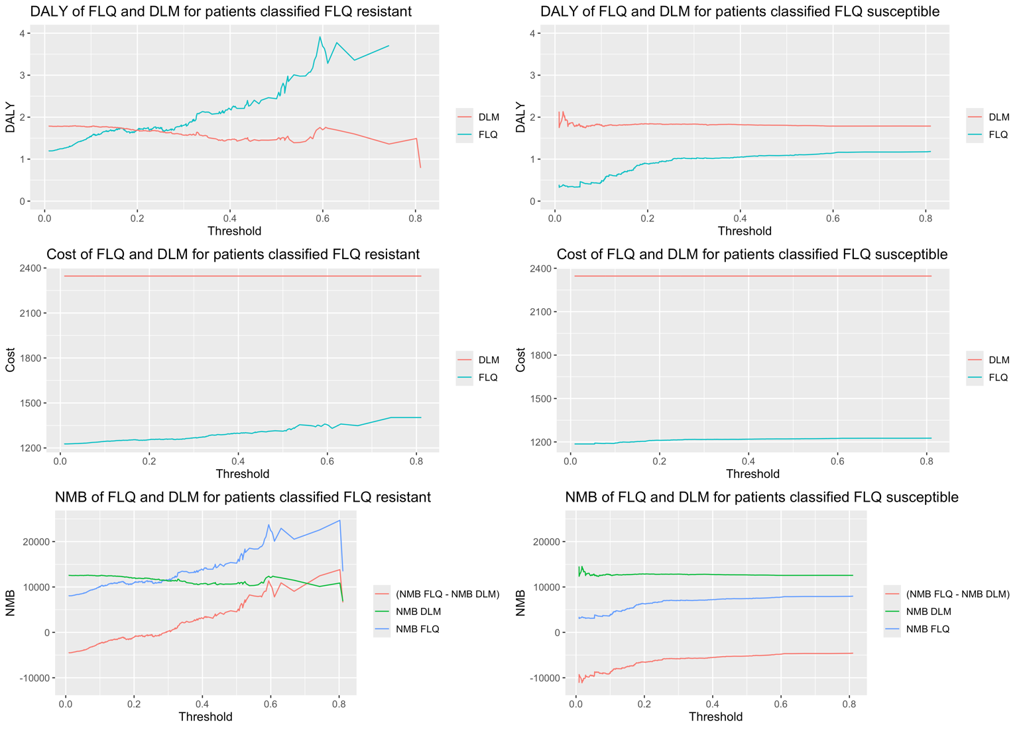

Change in NMB

$$NMB_{i}=GDP*\left(DALY_{SdTreat}- DALY_{PMDT_{T}}\right)-(Cos{t_{PMDT}}_{i}-Cost_{SdTreat})$$

SdTreat = Standard treatment
PMDT = Prediction Model + Decision Tree

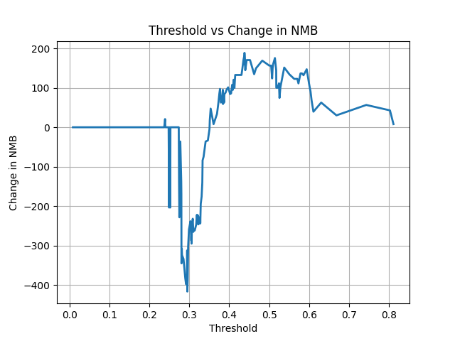

Change in DALYs (cumulative) by threshold when comparing PM + DT with the standard treatment

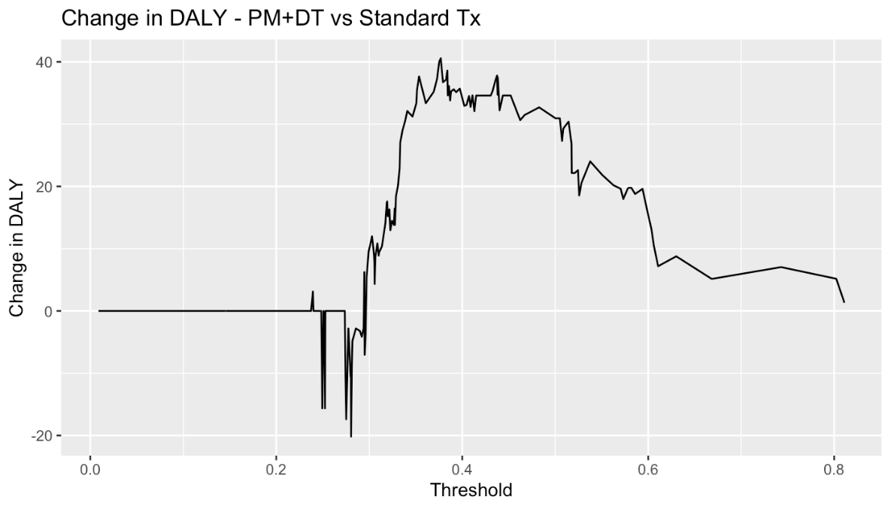

Change in Cost (cumulative) by threshold when comparing PM + DT with the standard treatment

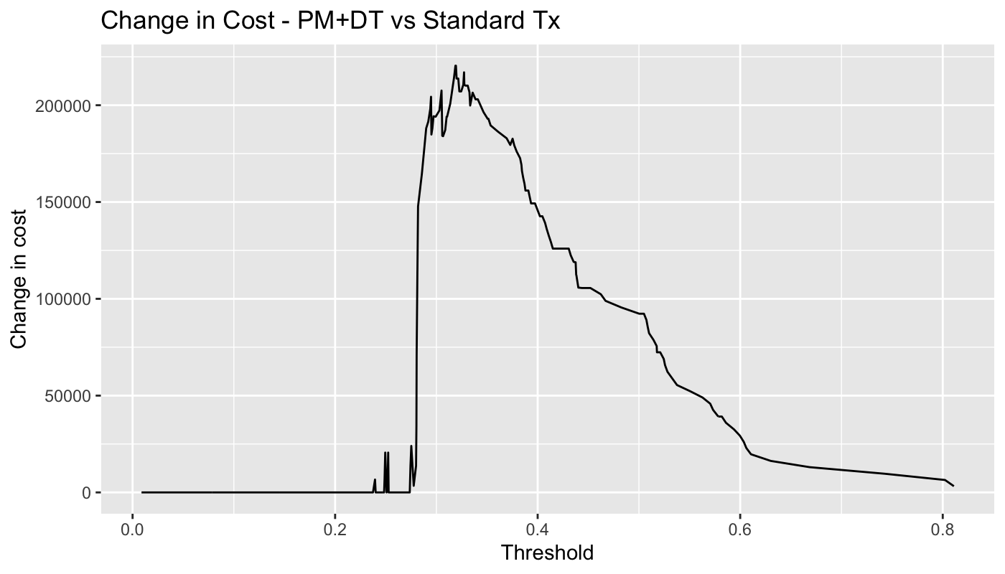

Change in health versus change in cost compared to the standard treatment

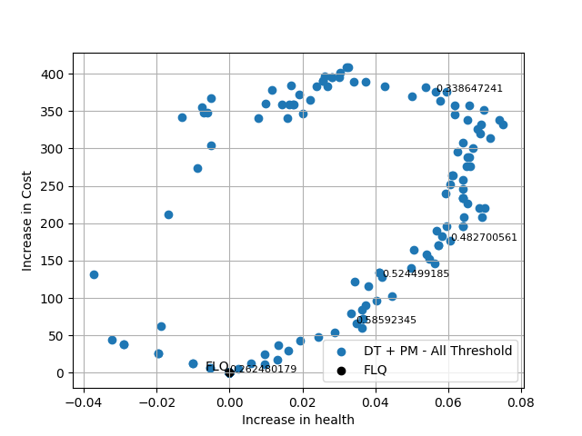

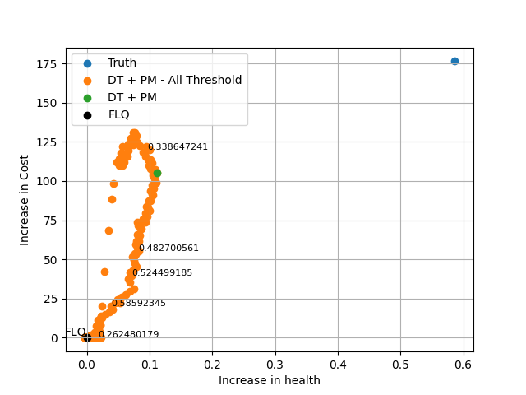

“Performance” of the DT+PM

Sensitivity: patients who are FLQ resistance who are given DLM.
Specificity: patients who are FLQ susceptible who are given FLQ.

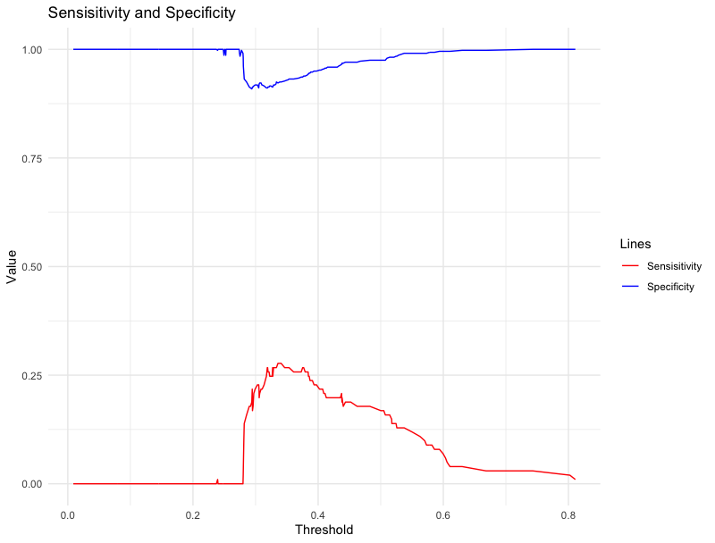

Number of patients who were prescribed DLM depending on their FLQ susceptibility classification by the prediction model.

Classified FLQ resistant: Class FLQ Res
Classified FLQ susceptible: Class FLQ Sus

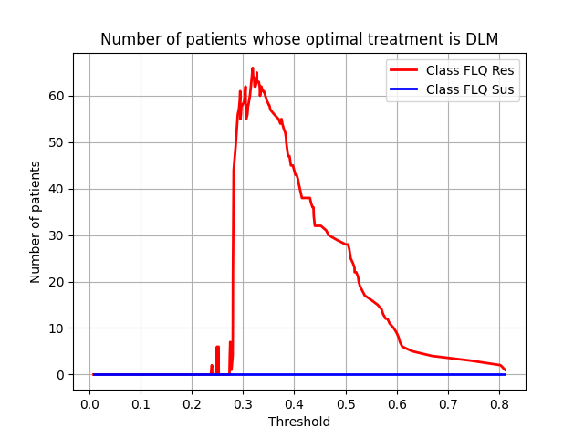

Change in DALYs when compared to the standard treatment for a patient prescribed DLM depending on FLQ Susceptibility.

$$Change in DALY = DALY_{SdTreat}-DALY_{PMDT}$$

The figure below shows the change in DALYs when a patient is prescribed FLQ given that they are FLQ resistant or susceptible depending on their age (and, as a consequence DALYs incurred by death). Notice that the DALY incurred from death depend on the age of the patient and, therefore, the change in DALYs will vary for different patient ages. The X axis represents the amount of DALY incurred by death (DD_0 is zero DALYS and DD_50 is 50 DALYs). The change in DALYs for a patient who is FLQ resistant and who is given DLM is positive (meaning $DALY_{SdTreat}>DALY_{PMDT}$) so the treatment improves health. The DALY value depends on the age, the younger is the patient, larger is the benefit). The change in DALYs for a patient who is FLQ susceptible and who is given DLM is negative, meaning that the treatment decreases health. The benefit of treatment FLQ resistant patients with DLM outweighs the decrease in health for treating FLQ susceptible patients with DLM (when the DALY incurred by death is the same).

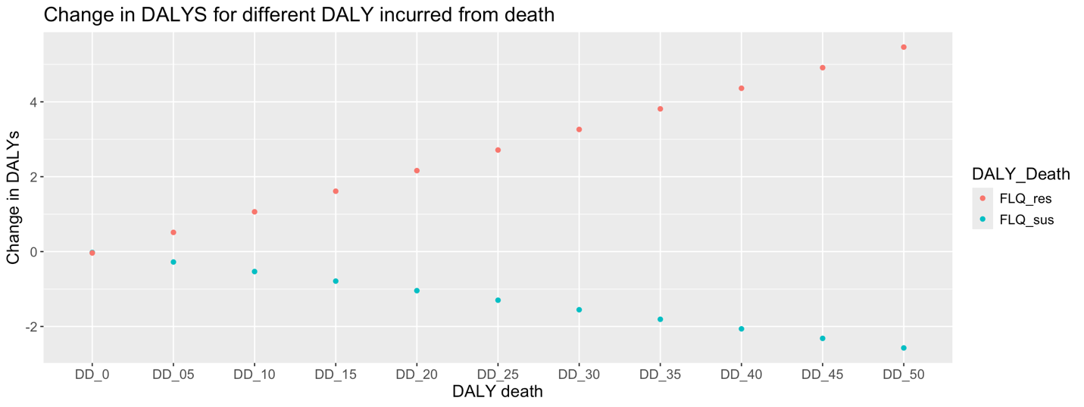

Change in cost when compared to the standard treatment for a patient prescribed DLM depending on FLQ Susceptibility.

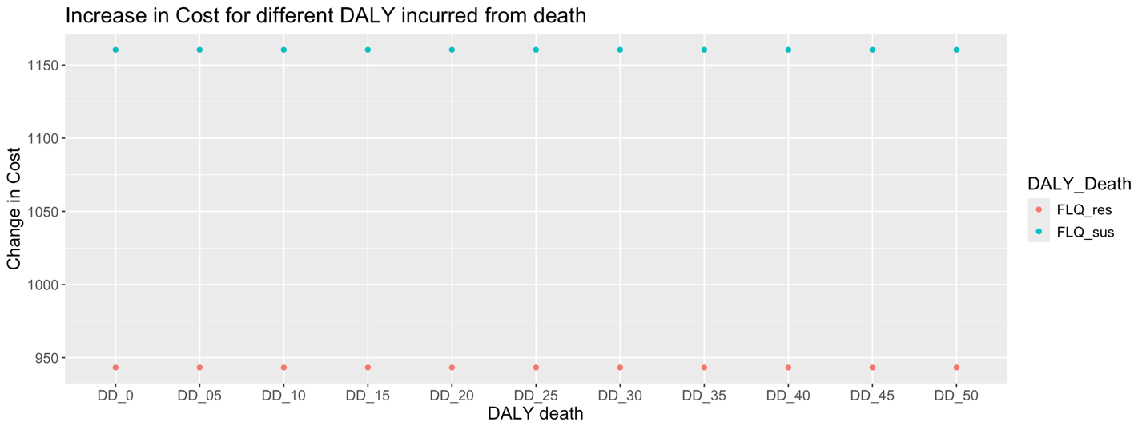

Change in health (when compared to the standard treatment) for people who are given the correct treatment and incorrect treatment and overall change in NMB when compared to the standard treatment

The figure below shows the change in health (cumulative) for people when given the correct and incorrect treatment and the change in NMB at each threshold. The health improvement derived from prescribing the correct treatment clearly outweighs the decrease in health resulted from prescribing DLM for patients who are FLQ susceptible for threshold larger than 0.35.

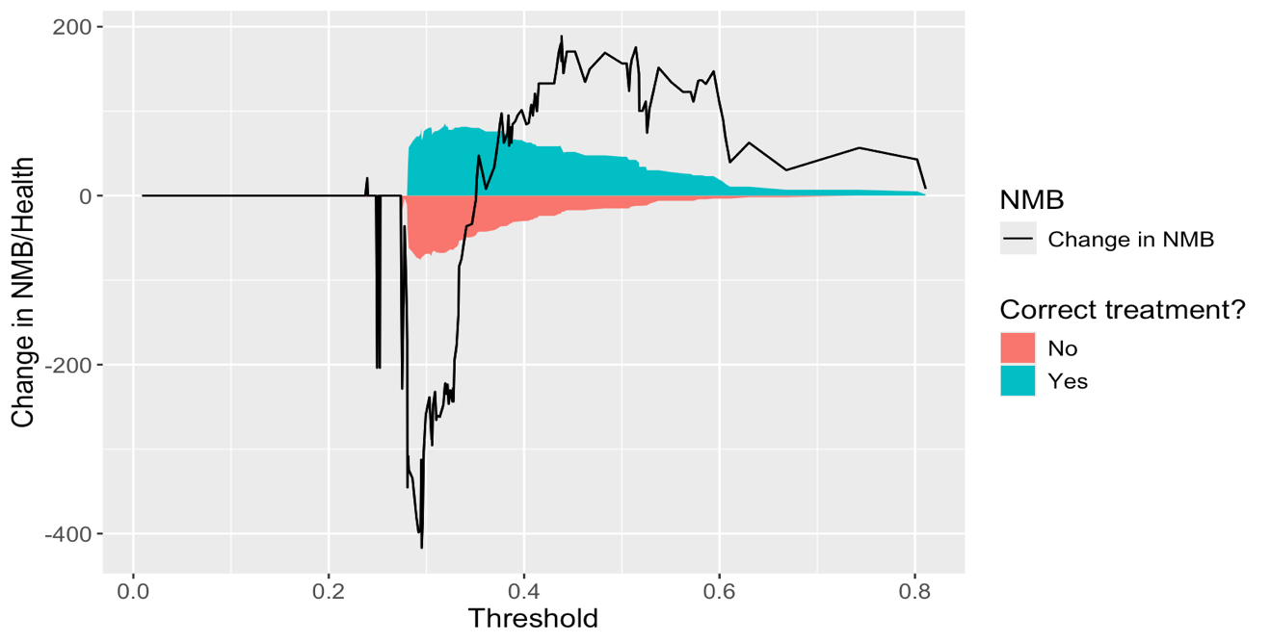

Proportion of people who would be prescribed the correct treatment using PM + DT

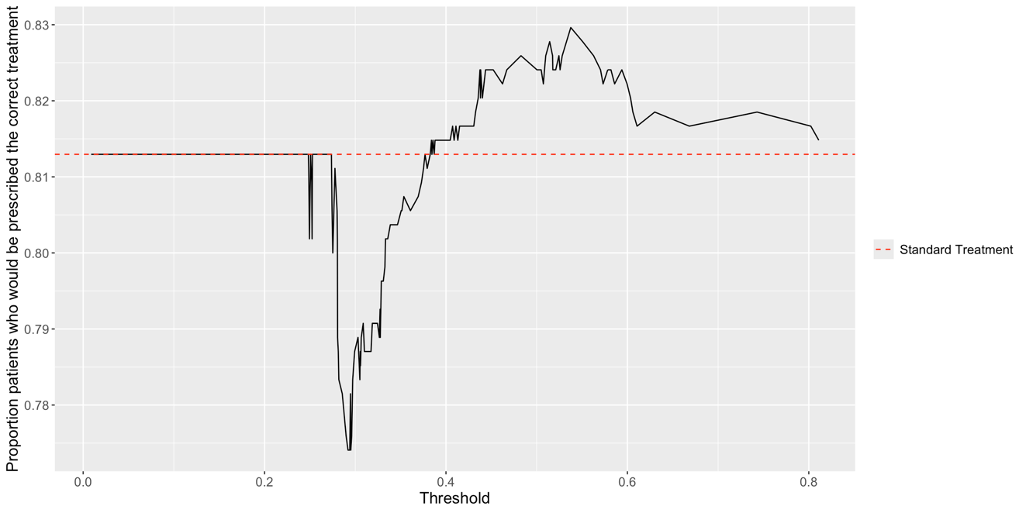

Prediction model alone: Change in Health and Cost

